**Step 1: Sign Up for AWS**

In order to get started, you’ll need to sign up for an AWS account.

This can be done via [aws.amazon.com](https://aws.amazon.com)

Find the button on the screen that says something like “Create an AWS account” or “Sign into the Console”. Usually it’s in the top right.

This should take you to the account creation / sign in screen that looks something like this:

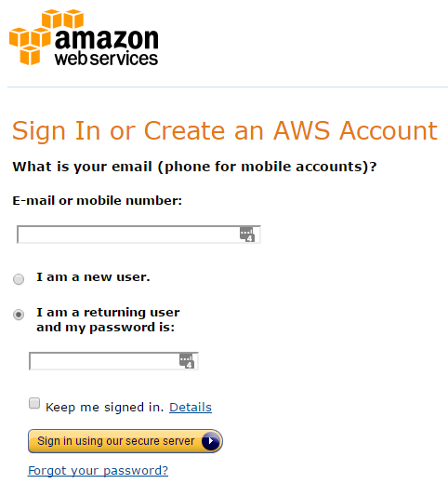

If you already have a regular Amazon account (like the one you use to shop on Amazon), then you can use this account to just sign in and get the process started.

Otherwise, click on the “I am a new user” radio button and type in an email address to create a new Amazon account.

If you’re creating a brand new account, then you’ll need to fill out some account information (name / email address / password) on the next screen. It should look something like this:

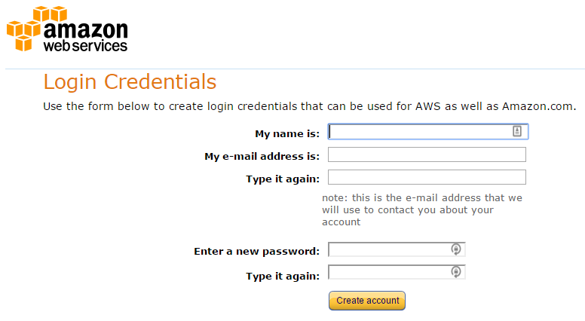

Next up is the screen you’ll see if you just logged in with your existing Amazon credentials (or if you just filled out the previous screen with your new account information).

Here you’ll need to tell AWS more about yourself or your business.

If you’re creating this account for your business, then choose the “Company Account” radio button. If you’re just signing up to use this for your own personal reasons (like creating apps for fun or just for learning purposes), then choose “Personal Account”.

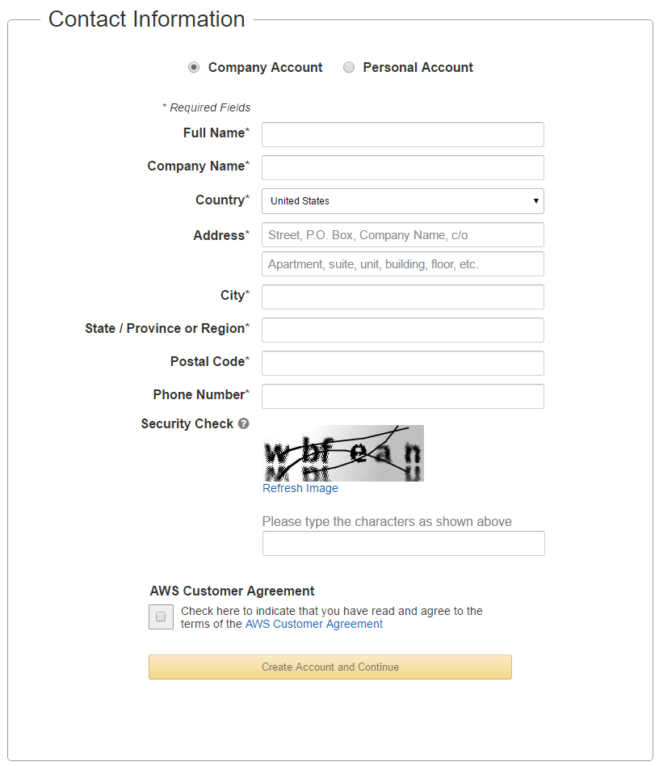

Once you’ve filled out all your personal / business information, you’ll need to give them your payment information.

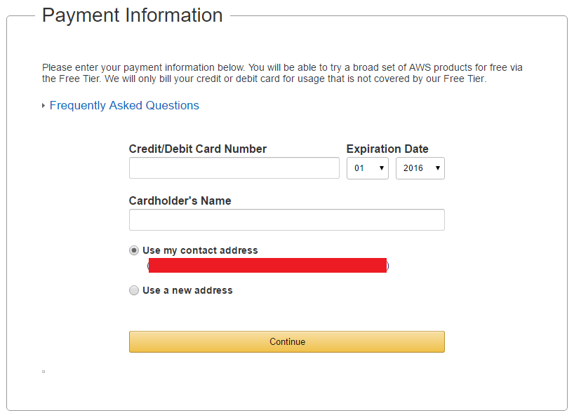

Next up, you’ll need to confirm your identity by receiving a phone call and either saying or typing in a PIN that you’re assigned. Go ahead and fill out your phone number and press the “Call me Now” button.

Once you hit “Call me Now”, you’ll be presented with a pin on a screen that looks like this:

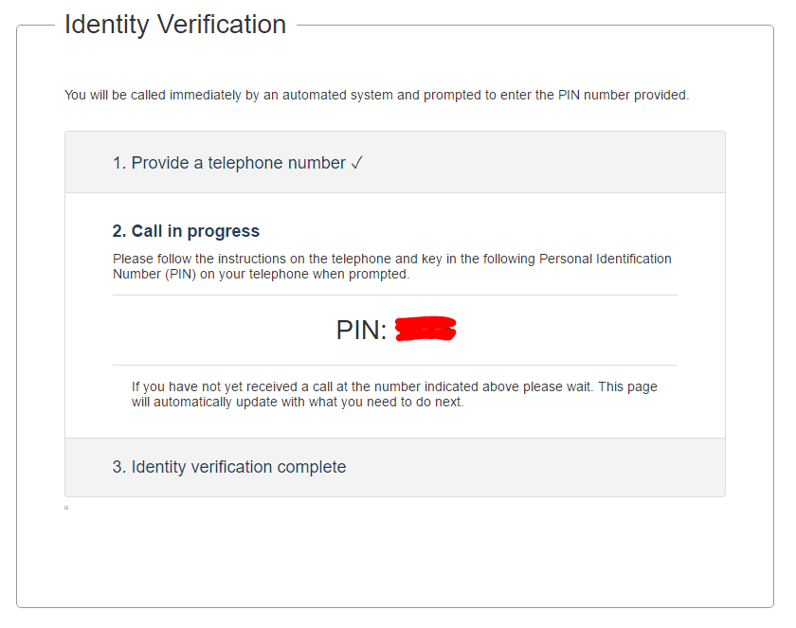

When your phone rings, pick it up and type in that PIN (or say it out loud) to verify your account.

When you’ve successfully entered your pin, you’ll see this screen:

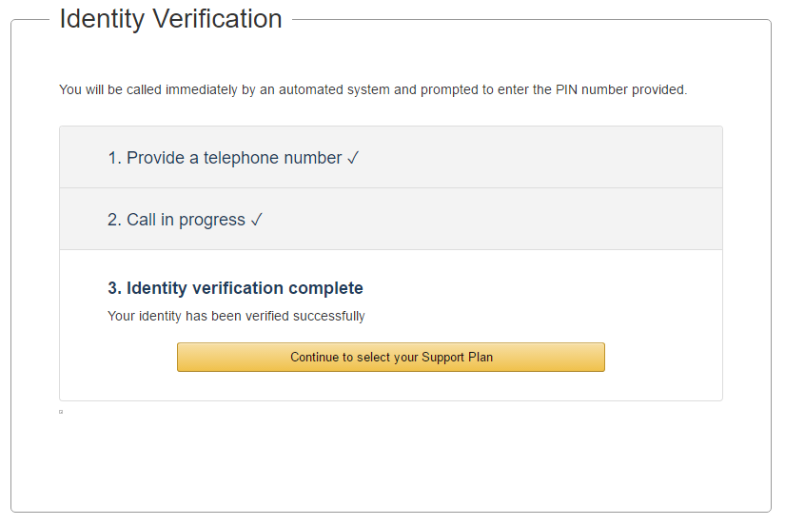

Go ahead and click on the button that says “Continue to select your Support Plan”.

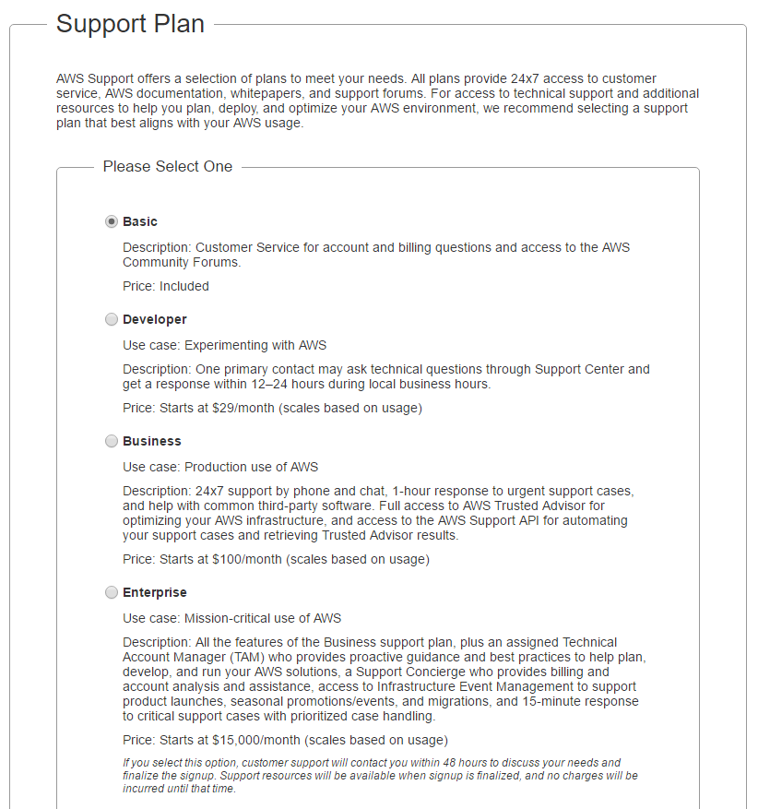

d.

Once you’ve signed in, you should see a Console / Dashboard that looks something like this:

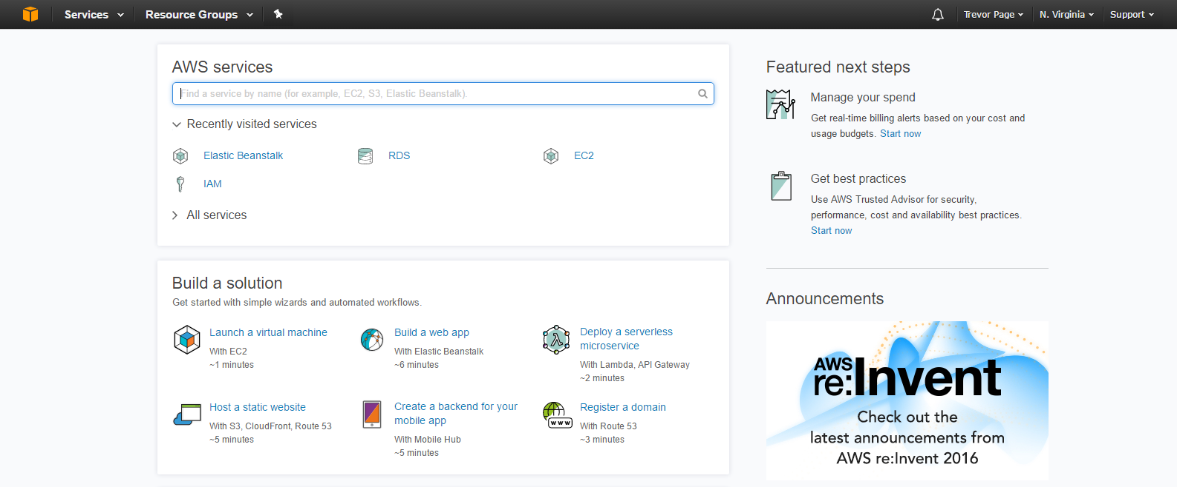

Amazon will likely make changes to their views over time, so your dashboard might not look exactly like the one pictured above.